Australian National Contact Point

Specific Instance Procedures

Version 2.0, July 2018

Contents
Foreword 2
Application and background 2
1. Introduction 3
2. Submitting a case 3
3. Initial assessment 4
4. Good offices 6
5. Final statement 7
6. Post-completion: follow-up 8
7. Post-completion: review 8
8. Timing 9
9. Confidentiality 10
10. Withdrawal of cases 10
11. Transitional arrangements 11
12. Glossary 11
Appendix A: AusNCP Specific Instance Handling Procedure 12

Foreword
The AusNCP is going through a period of change and renewal. As part of our response to the 2017 Independent Review, we may issue further changes to these procedures.
If further changes are made to the structure and operations of the AusNCP, we will ensure that any resulting changes to the procedures are subject to further consultation with our stakeholders.
Please direct any queries to the AusNCP Secretariat via email, ancp@treasury.gov.au or by phone, +61 2 6263 3777.

Application and background
The Australian National Contact Point (AusNCP) will receive complaints of specific instances regarding alleged non-observance of the OECD Guidelines for Multinational Enterprises. The procedures outlined in this document apply to all new cases from the date of publication. Refer to Section 11 for transitional arrangements for existing cases.
The OECD Guidelines for Multination Enterprises (the OECD Guidelines) are recommendations addressed by governments to multinational enterprises operating in or from adhering countries. They represent a global framework for responsible business conduct covering all areas of business responsibility including disclosure, human rights, employment and industrial relations, environment, anti-corruption, competition and taxation.
A copy of the OECD Guidelines, including OECD implementation procedures and associated commentary, is available in a range of languages at mneguidelines.oecd.org.
Companies operating in Australia and Australian companies operating overseas are expected to act in accordance with the principles set out in the OECD Guidelines and to perform to the standards they suggest. The OECD Guidelines supplement domestic law and are not legally binding.

Introduction
  - This document refers to specific instances as ‘cases’, the individual or entity making the complaint as the ‘notifier’ and the multinational enterprise as the ‘enterprise’.
  - Cases will be handled in line with the procedures documented herein. The AusNCP may alter components of this procedure (such as extending timeframes) in consultation with the parties.
  - The AusNCP Oversight Committee will provide advisory support to the AusNCP throughout handling of cases, as requested.
  - To support effective implementation of these procedures, the AusNCP will have regard to the OECD core structural principles of visibility, accessibility, transparency and accountability; and to the OECD procedural guidance for impartiality, predictability, equitability and compatibility with the OECD Guidelines.
  - A simplified flowchart of the process is provided at Appendix A as a guide.

Submitting a case

  - The notifier may be any interested party, however, generally they require a close interest in the issue in order to be able to supply the AusNCP with adequate information. Notifiers acting on behalf of others should be able to demonstrate their authority to do so.
  - A notifier should ordinarily submit a case through the form on the AusNCP website www.AusNCP.gov.au. If a notifier is unable to use the form, the AusNCP will seek to provide reasonable alternate arrangements to ensure the process is accessible (for example email, translation services, or connecting the notifier to a relevant third party for assistance in forming their case). Reasonable arrangements to ensure accessibility will be made for the duration of the case.
  - Specific instances can be made to the AusNCP about:
    - a multinational enterprise operating in Australia; or
    - an Australian multinational enterprise operating in a country that is not an adherent to the OECD Guidelines.

  - The AusNCP will seek to take a broad view of the definition of an Australian multinational enterprise for the purposes of receiving cases. Factors such as the entity’s corporate identity and scope of management or control in Australia will be considered.
  - Submissions should clearly demonstrate the link between the issue raised and the enterprise’s actions or responsibilities.

Initial assessment

  - The AusNCP will acknowledge receipt of a complaint within five (5) working days.
  - Where a submission does not contain key information necessary to conduct an initial assessment, the AusNCP will work with the notifier to ensure that the required material is provided and agree a reasonable timeframe for its provision. Incomplete submissions may be considered invalid if notifiers are unable to provide required information within a reasonable timeframe.
  - Submissions that concern a matter which the AusNCP or another National Contact Point (NCP) has already handled to completion may not be considered valid if the substance of the submission is not markedly different. The notifier will be informed if this occurs.
  - In line with the circumstances set out in the Procedural Guidance and Commentary in the OECD Guidelines, if the AusNCP considers that it is not the correct NCP to handle the case, it may seek to transfer the case to another NCP at any point during the initial assessment stage.
If a case is transferred to a different NCP, the AusNCP will inform the notifier and list the transfer on the AusNCP website.
  - In some circumstances, it may be appropriate for the AusNCP to work with another NCP throughout the handling of a case. In such cases, lead NCP and cooperating NCP status will be agreed between the relevant NCPs, the parties will be informed, and the procedures of the lead NCP would generally apply.
  - For all valid submissions, the enterprise named in the case will be notified and provided a copy of the specific instance submission. Following this, the complaint—including the name of the notifier—will be listed on the AusNCP website. Where details of the case are already in the public domain due to independent reporting (not by the parties), the name of the enterprise will also be listed.
  - Consistent with the Procedural Guidance and Commentary in the OECD Guidelines, in deciding whether to accept a case, the AusNCP will consider whether the issue/s raised merit/s further examination by determining whether the issue is bona fide and relevant to the implementation of the OECD Guidelines. In this context, the AusNCP will take into account:
    - the identity of the party concerned and its interest in the matter;
    - whether the issue is material and substantiated;
    - whether there seems to be a link between the enterprise’s activities and the issue raised in the specific instance;
    - the relevance of applicable law and procedures, including court rulings;
    - how similar issues have been, or are being, treated in other domestic or international proceedings; and
    - whether the consideration of the specific issue would contribute to the purposes and effectiveness of the OECD Guidelines.
  - To promote accessibility, the AusNCP will interpret ‘material and substantiated’ to mean that the issues are plausible and related to the application of the OECD Guidelines, and that there is a plausible link between the enterprise’s activities and the issues raised.
  - The outcome of the initial assessment will be conveyed to the notifier and enterprise. It will also be recorded on the AusNCP website.
  - Where the AusNCP rejects a case, a final statement will be prepared and published in line with the procedures below.
  - Where the AusNCP accepts a case, the good offices process will commence. The identity of the enterprise will be listed on the website if it was not listed previously. The AusNCP will invite the enterprise to make a written submission in response to the complaint.
  - Acceptance or rejection of a case is not an assessment of whether the enterprise’s actions are consistent with the OECD Guidelines.

Good offices

  - The good offices process will begin with a preparation stage to enable the AusNCP to provide information to the parties on the specific instance process and prepare a framework for handling of the case. This will be followed by a proceedings phase for discussion of the issues with a view to a resolution.
In practice, the AusNCP expects that the good offices process will differ from case to case and will retain a flexible approach to delineation between the preparation and proceedings stages.
  - To begin the preparation stage of good offices, the AusNCP will seek to engage each party separately to explain the overall AusNCP process and options for discussion of the issues. Once received and subject to any confidentiality considerations outlined in these procedures, the AusNCP will also share the enterprise’s response to the case with the notifier.
  - In consultation with the parties, the AusNCP will prepare a plan for proceedings in order to give clarity to the process and manage timeframes and expectations. Plans may include each party’s initial objectives for discussion, anticipated communication methods and confidentiality requirements, including whether a formal confidentiality agreement is required. Plans may vary in formality (e.g. an email or a structured document) and will be case specific, to account for the preferences of each party and any practical constraints that may exist.
  - The AusNCP will seek each party’s agreement to proceed with discussions and if:
    - both parties agree, the proceedings will commence;
    - the notifier does not agree, the AusNCP will prepare a final statement summarising the process followed to date but will not make any further assessment of the issues raised; or
    - the enterprise does not agree, the AusNCP will prepare a final statement which will include further assessment of the issues raised.
  - Where the proceedings involve formal mediation, the AusNCP may use a suitably qualified third party to conduct the proceedings.
  - At regular intervals the AusNCP will review the progress of proceedings. When the AusNCP considers discussions are no longer effective, the issues are resolved or the parties do not require the AusNCP’s involvement to continue, it will conclude the good offices process. The AusNCP will consult both parties before making this decision and provide an update on its website.

  - Following the conclusion of the good offices process, a final statement will be prepared. Both parties may be invited to make a further written submission to support the AusNCP’s consideration of the case.

Final statement

  - The AusNCP will draft a final statement following the rejection of a case or the conclusion of good offices.
  - To prepare a statement the AusNCP will review the materials provided by the parties and may also review publicly available information and other information revealed through the good offices process. Advice may also be sought from a range of sources including the AusNCP Oversight Committee, another NCP, the OECD Secretariat or subject matter experts.
  - All final statements will include an overview of the case and a description of the process undertaken by the AusNCP.
Where the case was rejected, the final statement will also include an explanation of how the submission was assessed as per section 3.6 of these procedures.
  - Where the case was accepted but good offices did not result in an agreed outcome, the AusNCP will include in the final statement an examination and analysis of the issue and may include a statement as to whether the enterprise’s actions were consistent with the OECD Guidelines.
The AusNCP’s final statement will include recommendations to the enterprise where appropriate.
  - If it is considered useful and in consultation with the parties, the AusNCP may initiate or resume the good offices process at any point during the drafting of a final statement.
  - Once the AusNCP has drafted its final statement, it will be provided to both parties for comment. The AusNCP may make changes at its discretion.
  - The final statement will be published on the AusNCP website and reported to the OECD. The AusNCP has discretion to accommodate any reasonable requests from either party in relation to sensitivities around publication content or timing.

Post-completion: follow-up

  - The AusNCP will specify a timeframe for follow-up on the case in the final statement, provided this is appropriate in the context of the issues involved.
  - In these cases, the AusNCP will request an update from both parties on developments since the completion of the final statement.
  - The AusNCP may publish a further statement with a summary of the updates received and any commentary on the matter that it considers relevant. It may also recommend an additional follow-up period in circumstances where it considers this may be useful.
  - Once the AusNCP has drafted its follow-up statement, it will be provided to both parties for comment. The AusNCP may make changes at its discretion.
  - The follow-up statement will be published on the AusNCP website.

Post-completion: review

  - Where either party considers that the AusNCP has not acted in line with these procedures, they may request a procedural review within 10 working days from receipt of the final version of the AusNCP Final Statement. Late requests for review may be considered where an adequate reason for the delay is provided.
  - Requests can be made in writing to the AusNCP by email or post according to the contact information listed on the AusNCP website. The request must identify the final statement to be reviewed, the procedural irregularity and why the party thinks it should be reviewed.
  - The AusNCP will notify receipt of a review request within five (5) working days and send a copy of the request to the other party to the case.
  - The request for review will be referred to a senior executive within the Australian Treasury of at least one level higher than the AusNCP and who was not involved in the handling of the original case. This person will be known as the reviewer.
  - The AusNCP will provide the reviewer with written comments on the review request and any background information it considers relevant to the review. Subject to any confidentiality considerations, this information will be made available to the parties if requested.

  - The reviewer will investigate the review request to determine if there are grounds for concern about the procedural matters raised. The reviewer may make enquiries to inform their decision. To facilitate these inquiries, the reviewer may share the request for review or seek submissions from any person involved in the original matter (including the parties). The reviewer may also consult with members of the AusNCP Oversight Committee, other NCPs or the OECD Secretariat.
  - The reviewer will provide their written assessment to the AusNCP and both parties. If the reviewer determines that material procedural irregularities occurred, they may:
    - remit the decision back to the AusNCP with instructions on how to rectify the procedural irregularity; or
    - acknowledge that there were deficiencies in the AusNCP’s handling of the case and make recommendations as to how those errors can be avoided in the future.
As the review is strictly procedural, the reviewer will not examine the substance of any AusNCP decision and will not replace the AusNCP decision with their own decision.
  - If the decision is sent to the AusNCP for reconsideration, the AusNCP will re-open the case in accordance with the instructions of the reviewer, correct the deficiencies and, if necessary, reconsider its final statement. No further request for review of that action may be made.
  - The reviewer will prepare a public statement detailing the request for review, the review process undertaken and their assessment, including any recommendations, for publication on the AusNCP website.

Timing

  - The following table provides timeframes for each phase of the AusNCP case handling process. Timeframes are indicative of ideal scenarios and cases may take longer.
Phase | Duration
Initial assessment | 8-10 weeks
Good offices – preparation | 10 weeks
Good offices – proceedings | 15-20 weeks
Final statement | 15 weeks
TOTAL | 48-55 weeks
Review | 15 weeks
  - Where delays are anticipated or ongoing the AusNCP will discuss the reason/s with the parties and consider available options to suitably manage the delay. Where delays are significant (greater than 5 weeks) or affect multiple cases this will also be noted on the AusNCP website.

Confidentiality

  - It is important for the parties to have confidence that information provided to the AusNCP will be treated sensitively. It will not be released publicly by the AusNCP without consultation and will only be shared on a confidential basis with those who have a direct role in assisting the AusNCP in considering the case (for example, members of the AusNCP Oversight Committee, service providers such as translators and mediators, other government officials, other NCPs).
  - Information provided by any party to a case will only be shared with the other party to the case with the consent of the party that provided the information. If a party does not agree to share information, the AusNCP will assess whether this is reasonable in the circumstances and where possible, work with the relevant party to excise any sensitive information that may otherwise limit the sharing of the information. Information that cannot be shared between the parties may not be able to form part of the AusNCP’s consideration of the case.
  - Information shared between the parties should be kept confidential, including following the conclusion of the AusNCP process, unless the providing party agrees to its disclosure or this would be contrary to the provisions of a national law.
  - Parties should be aware that information and documents provided to the AusNCP will be subject to the operation of the Freedom of Information Act 1982 (FOI Act) and could be released under the provisions of that Act. The FOI Act sets out a process for ensuring the public’s right to access documents held by government, but it does not prevent agencies from disclosing information outside that process.
  - Parties should also be aware that the Australian Parliament can seek the production of information and documents from the AusNCP.

Withdrawal of cases

  - Notifiers may request to withdraw their case in writing to the AusNCP. If this occurs the AusNCP will consult the enterprise and close the case. The AusNCP will handle public acknowledgment of withdrawn complaints on a case by case basis.

Transitional arrangements

  - These procedures come into effect for all cases submitted to the AusNCP from the date of publication on this document.
  - Cases submitted prior to the publication date will be transitioned to these procedures at the next phase in the case, in consultation with affected parties.

Glossary

  - The following key terms are defined for the purpose of understanding this procedural guidance.
OECD: Organisation for Economic Cooperation and Development.
OECD Guidelines: the OECD Guidelines for Multinational Enterprises.
AusNCP: the Australian National Contact Point.
Oversight Committee: the formal advisory body to the AusNCP.
Terms of reference available at www.AusNCP.gov.au.
Specific instance/ Case: A complaint concerning an enterprise’s conduct in relation to the OECD Guidelines. The terms specific instance and case are synonymous.
Notifier: The individual or entity who submits a case to the AusNCP.
Enterprise: The multinational company against which the complaint is made.
Parties: The notifier and the enterprise.

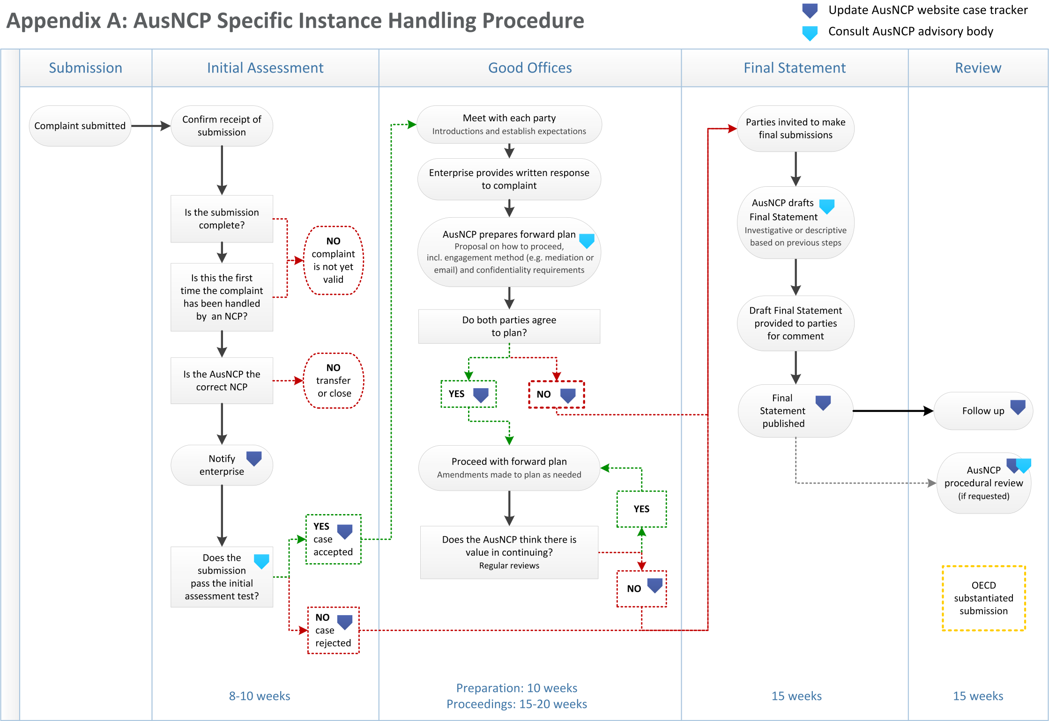
ppendix A: AusNCP Specific Instance Handling Procedure

Page 79, OECD Guidelines for Multinational Enterprises 2011.
Further information on page 82, OECD Guidelines for Multinational Enterprises 2011.

